**EAuction Solution Structure:**

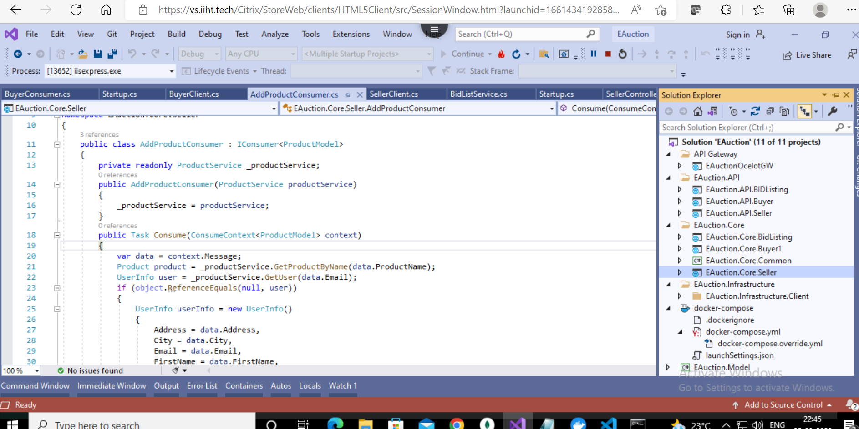

API with swagger

Seller API

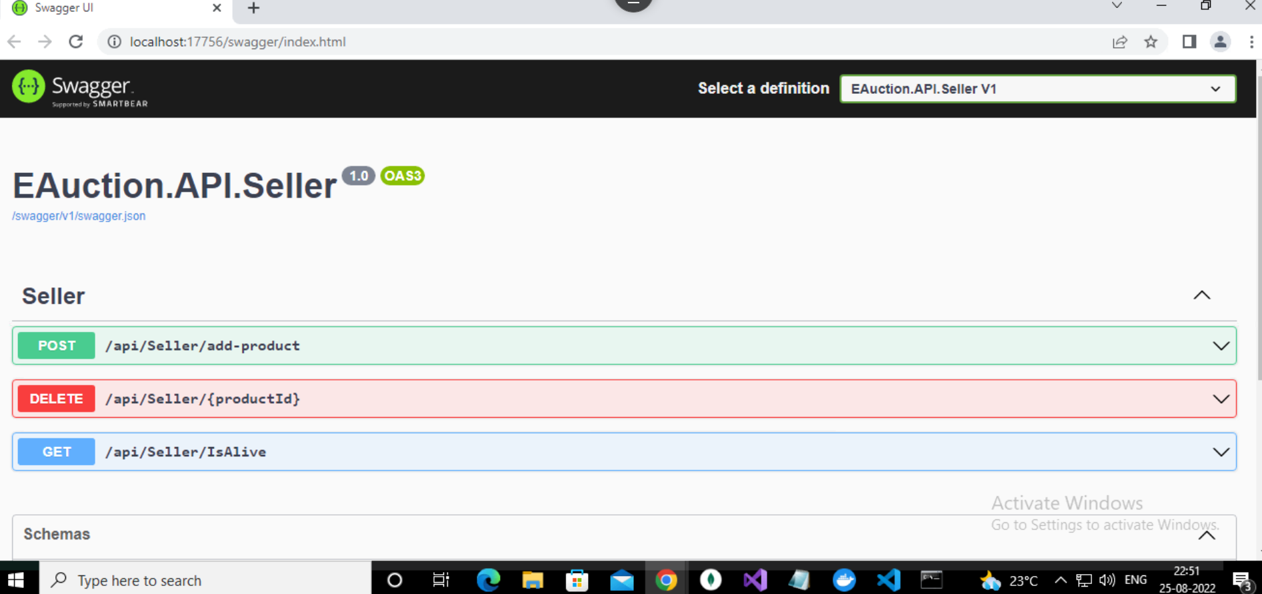

Add product

Mongo Db : Product

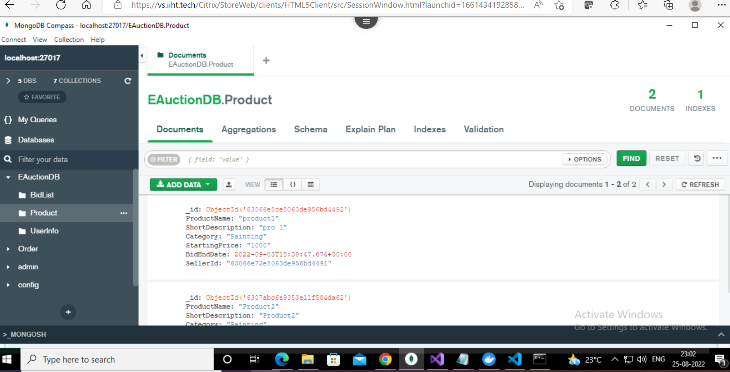

Buyer API

Place bid

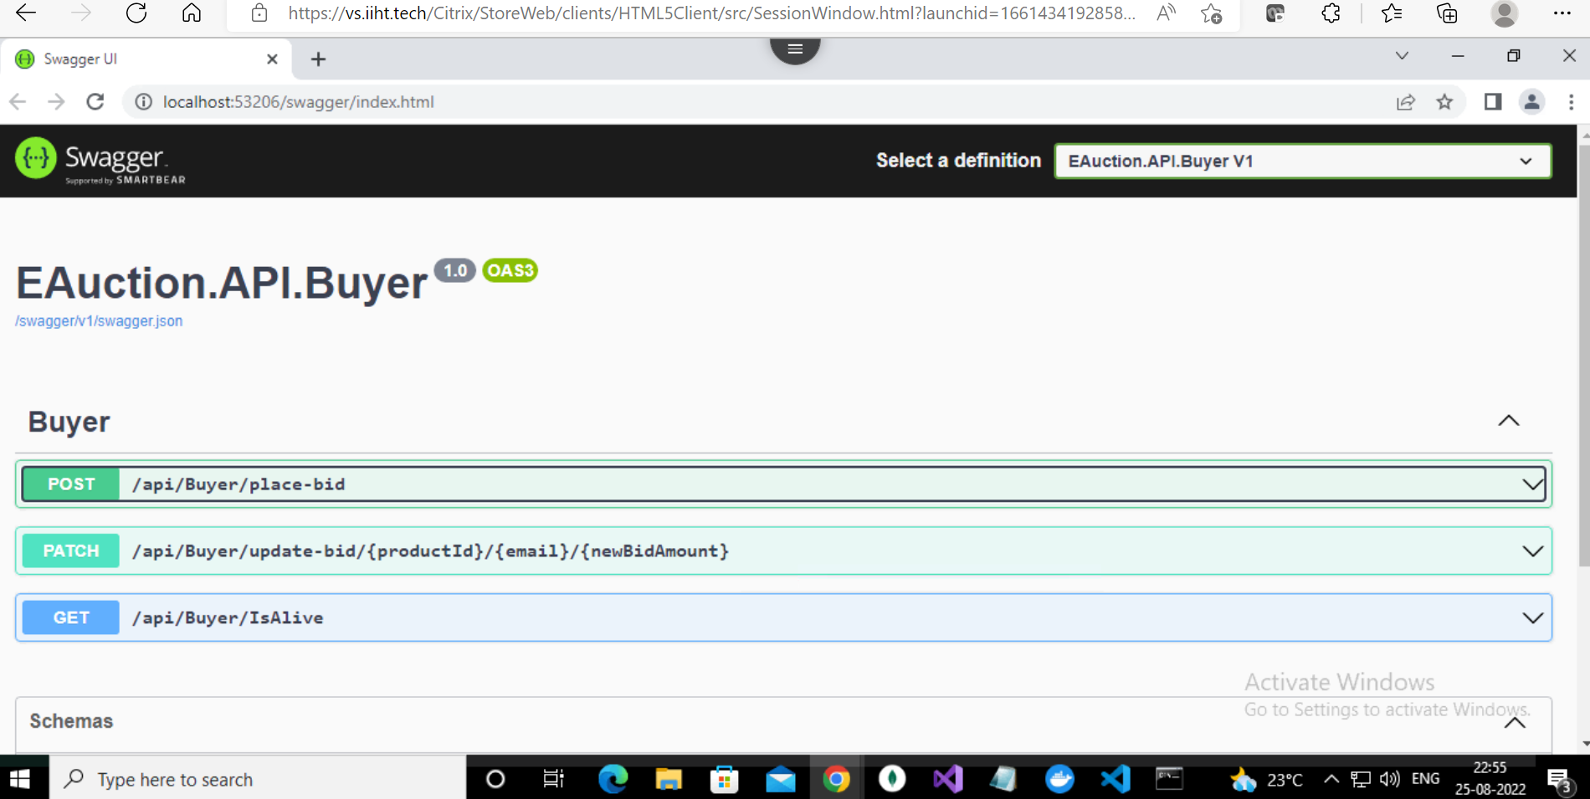

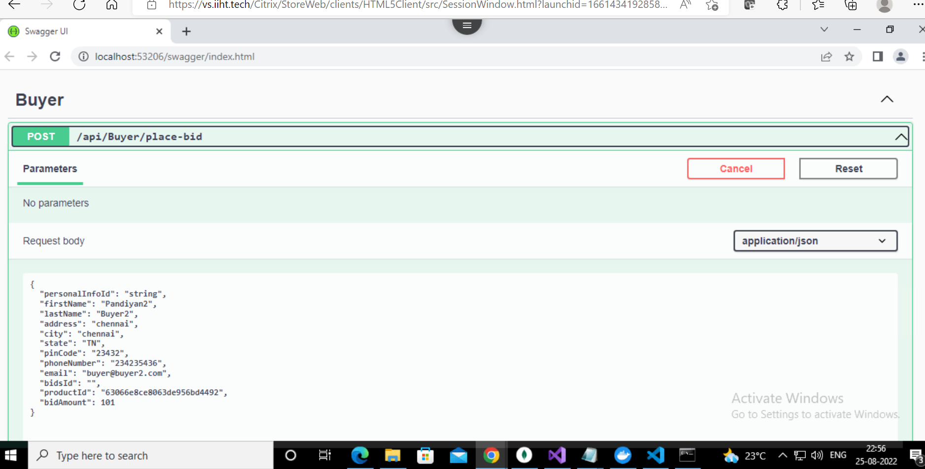

Mongo DB : Bid List

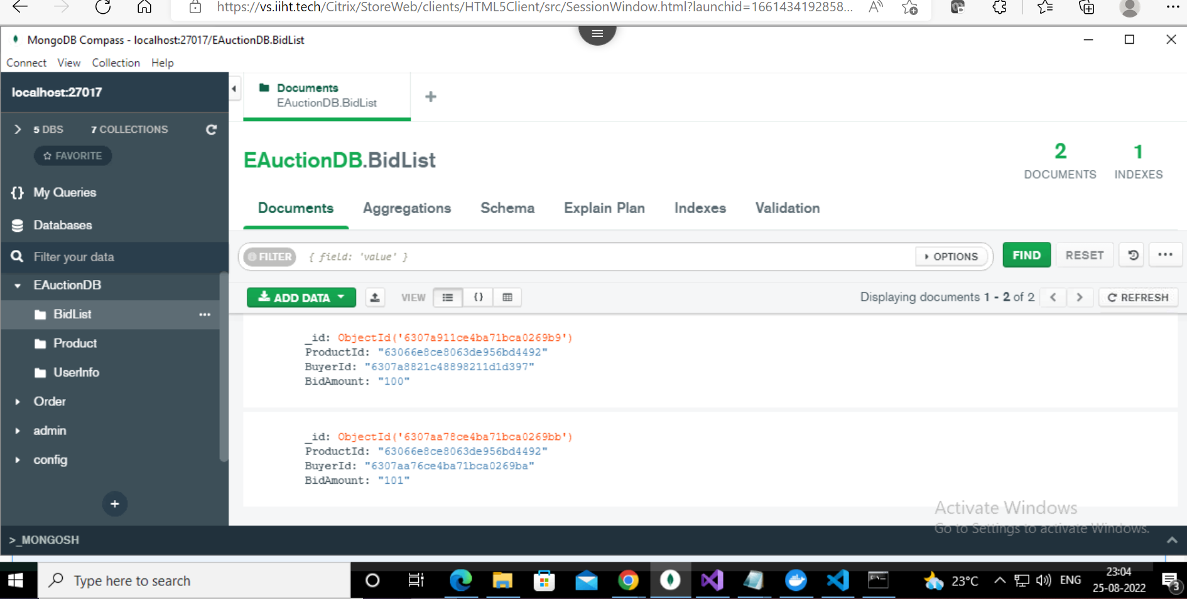

BidList API

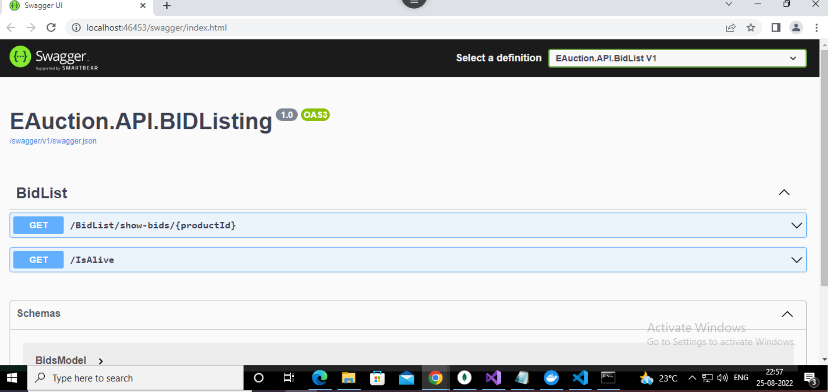

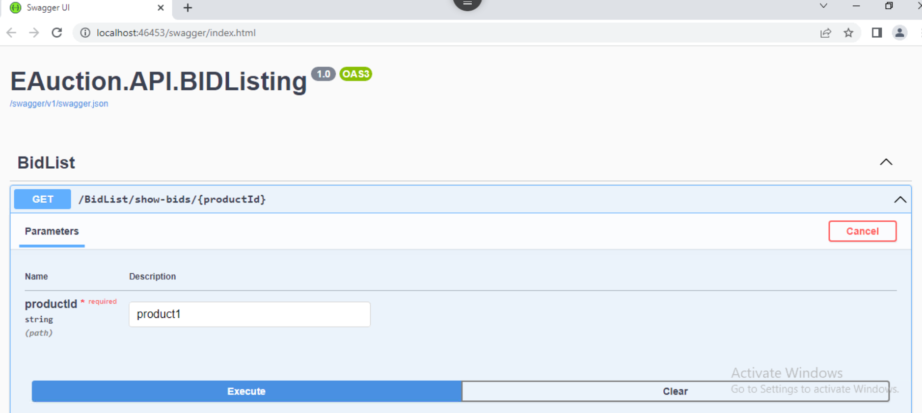

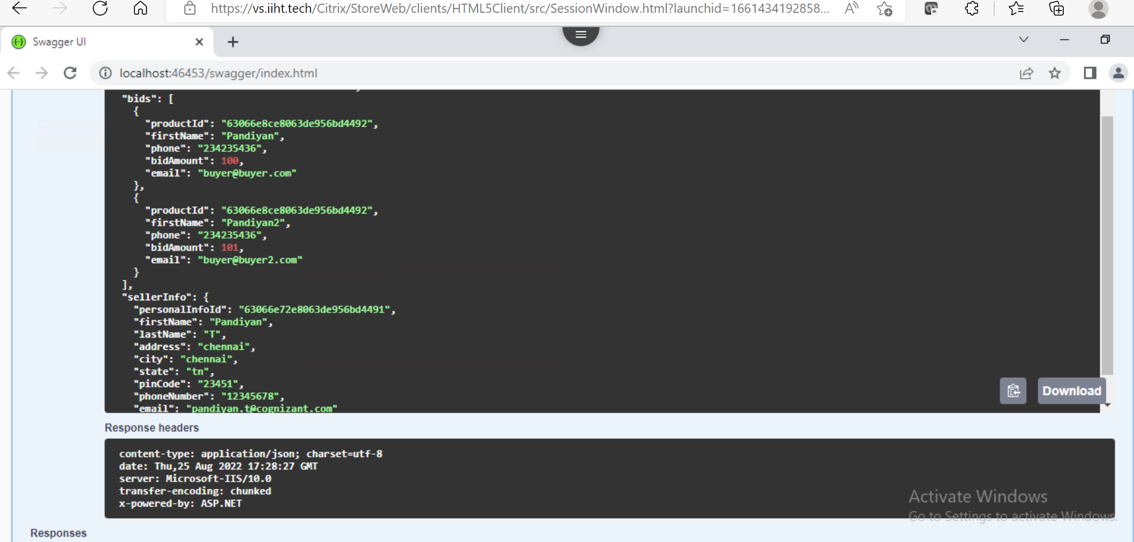

Docker:



